- League Safety Officer: Leann Svir
- Americans Little League will distribute a copy of this safety plan for all Managers/coaches, league volunteers, and the district administrator.

- EMERGENCY PHONE NUMBER: 911

GREAT FALLS POLICE: 406-771-1180
GREAT FALLS FIRE DEPARTMENT:406-727-8070
League President: Will Garten
League VP: Mike Davis
Secretary: Leann Svir
Treasurer: Tamara Wyatt
Player Agents: Juniors/Seniors: Wil Garten
Majors: Wil Garten
Minor A: Carey Amato
Minor B: Derek Frank
Tball: Leann Svir
Softball: Leah Sturgis
Maintenance: Scott Banderob
Equipment Manager: Wil Garten
Umpire’s Director: Jeff Ball
Umpire’s Coordinator: Board Members
Coach’s Coordinators: Player agents
Sponsor Coordinator: John Huber
Safety Officer: Leann Svir 406-799-2460
Info/Pr Tech Officer: Joe Marten
Volunteer Coordinator: Board Members
Uniform Coordinator: Will Garten
Game Scheduler: Player Agents

THIS LIST WILL BE POSTED AT THE CONCESSION STANDS.

- The Americans Little League will use the Official Little League volunteer application form to screen all of our volunteers.

- Managers/Coaches Meeting: The Americans Little League will have a coach’s meeting for the 2023 season on March 15th and April 4, 2023. Items will include team managers, board members, first aid information, and informative files.

- First Aid Training: This will be set for the 2022 season on March 15th and April 4, 2023 and all teams will be required to have a minimum of one Manager/Coach qualified on the team. Concussion training is scheduled for March 15th and April 4, 2022.

- Manager/Coaches will be required to walk/inspect all fields before practice and games to ensure they are no hazards. Umpires are also required to walk all fields before games to ensure no hazards exist.

- The Americans Little League has completed and updated the 2023 Facility Survey online.

- Concession Stand Safety:
- The menu will be posted and approved by the League Safety Officer and League President
- The concession stand safety procedures will be posted several times in the stand. Also, a copy will be in this packet.

- The League Equipment Manager and Safety Officer will inspect all equipment in the pre-season.

Managers/Coaches will be required inspect all equipment before all practices and games.

Umpires will be required inspect all equipment before games.

- Accident Reporting: The Americans Little League will use the provided incident tracking for from the LL webpage and the Manager/Coach will provide a completed Accident form to the Safety Officer within 24-48 hours of incident. A copy of the form will be in this packet.

- Each team will be issued an updated First Aid Kit and it is a requirement to have it at all practices and games.

- Americans Little League will require ALL TEAMS to enforce ALL LITTLE LEAGUE RULES. Including proper equipment for catchers.
- NO on deck batters.
- Coaches will not warm up pitchers
- Bases will disengage on all fields.

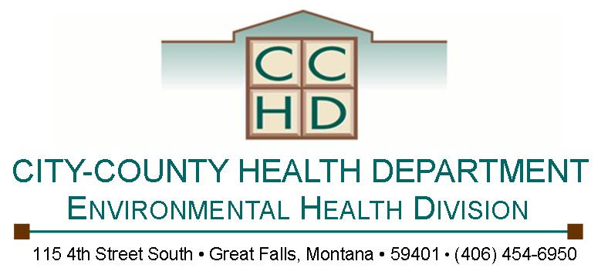

MINIMUM REQUIREMENTS FOR SAFE FOOD HANDLING

- Minimum holding temperatures: Hot food: 135°F or hotter Cold food: 41°F or colder.

- Reheat food items to a minimum of 165°F within 2 hours in an uninterrupted process.

- A metal stem food thermometer (0°F-220°F) must be available to check temperatures of food items, and accurate thermometers are to be located in cold holding units.

- Proper thawing procedures: Thaw under cold, running water (less than 70°F) or in fridge (41°F or below)

- Hands must be washed thoroughly before putting on disposable gloves or handling food and after visiting a restroom, smoking, eating, drinking, or handling raw meats, garbage, soiled linens, or dirty dishes for example. Food handler gloves must be worn and duties divided among food handlers to eliminate cross-contamination. Disposable food handler gloves must be worn when handling or serving ready to eat foods and cooked or finished product

- Exclusion of ill individuals from food handing tasks. For example: persons with diarrhea, vomiting, Jaundice, sore throat with fever, skin infection, open or draining wounds, upper respiratory infection or a communicable disease cannot prepare food.

- Keep the handling of raw products separate from the handling of cooked or finished products.

- Clean and sanitize food contact surfaces (ie. tables/counters/ cutting boards) prior to the event and frequently throughout the day and always after contact with raw meats. For a sanitizer solution, mix water and bleach (chlorine) or quaternary ammonium (QA) in a bucket. Check concentrations of sanitizing solution with test strips. MT Food Rule - Chlorine: 100 ppm. QA: 200 ppm. When wiping cloths are not in use, they must be stored in the sanitizer bucket.

- Wash all raw fruits and vegetables before being served or cooked.

12. Properly clean and sanitize all utensils and dishes prior to the event. Wash, rinse, sanitize, and air dry. Sanitize food contact equipment using chlorine (100 PPM) or quaternary ammonia solution (QA). If equipment such as knives, tongs, spatulas etc. are used continuously, clean and sanitize at least every 4 hours during service time of event.

